**RAJALAKSHMI ENGINEERING COLLEGE,THANDALAM.**



**INTERNET PROGRAMMING PROJECT REPORT**

**“FLAVOR FINDS”**

NAME: SADHANA A

ROLL NO:220701235

CLASS: CSE D

SEM: V

ACADEMIC YEAR: 2024-25

**INDEX**

ABSTRACT………………………………………………………3

INTRODUCTION………………………………………………..4

i.OBJECTIVE

ii.TARGET AUDIENCE

iii.SCOPE

TECH STACK AND TOOLS…………………………………….6

SYSTEM DESIGN………………………………………………7

USER INTERFACE……………………………………………..8

BACKEND IMPLEMENTATION……………………………...11

CHALLENGES AND FUTURE SCOPE……………………….13

**ABSTRACT:**

**“Flavor Finds”** is a web-based platform designed to connect food enthusiasts by allowing them to share, discover, and engage with diverse recipes. Developed using PHP, HTML, CSS, Bootstrap, and powered by a XAMPP server, Flavor Finds offers a dynamic recipe-sharing experience. Users can create accounts to upload and view recipes, as well as interact with other users by liking, commenting on, and sharing recipes. This platform aims to foster a community of home cooks, aspiring chefs, and food lovers by providing an easy-to-use interface for recipe sharing and culinary inspiration. With its responsive design, secure user authentication, and interactive functionalities, Flavor Finds strives to offer a seamless experience for all users. The project also includes robust backend management for efficient data storage and retrieval, utilizing a MySQL database to maintain user information, recipe content, and interaction data.

**INTRODUCTION:**

**i.OBJECTIVE:**

The primary idea behind Flavor Finds is to create a digital community where food enthusiasts can share, discover, and engage with recipes from around the world. The platform is designed to allow users not only to upload their unique recipes but also to connect with others through interactions such as likes, comments, and shares. Flavor Finds aims to make cooking and sharing recipes an interactive and enjoyable experience, encouraging people to explore a variety of culinary creations, experiment with new dishes, and learn from each other. The platform serves as a go-to source for diverse recipes, promoting a collaborative cooking culture where users can share their culinary insights and get inspiration from others.

**ii.TARGET AUDIENCE:**

Flavor Finds is intended for a broad audience of food lovers, ranging from beginners to seasoned home cooks and aspiring chefs. The website caters to those who enjoy cooking at home, experimenting with recipes, and sharing their culinary skills with others. Additionally, food enthusiasts looking for new recipes, inspiration, or cooking techniques would find the platform valuable. Whether users are seeking specific recipes, want to explore popular dishes, or enjoy browsing a variety of cuisines, Flavor Finds provides a space for everyone with a passion for food.

**iii.SCOPE:**

The project covers several key functionalities aimed at creating an engaging and interactive recipe-sharing platform:

1. **User Authentication**: Users can create an account and log in securely. This feature ensures that each user has a personalized experience on the site, allowing them to manage their profile and interact with content in a meaningful way.
2. **Recipe Uploading:** Registered users can upload their own recipes to share with the community. Each recipe includes fields for ingredients, steps, and optional images, allowing for a detailed recipe presentation. This feature empowers users to contribute their culinary creations and helps to build a rich database of diverse recipes.
3. **Interacting with Content:** Flavor Finds encourages user interaction through social features like liking, commenting, and sharing. Users can like recipes they enjoy, leave comments to share feedback or ask questions, and share recipes with others. These features are essential for fostering a sense of community among users, making it a lively space for food lovers to connect.

**TECH STACK AND TOOLS USED:**



**PHP**: Server-side scripting for handling back-end operations.

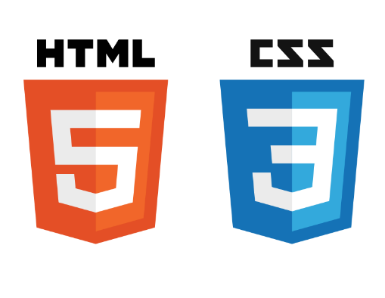

**HTML/CSS**: Structuring and styling the website.



**Bootstrap**: For responsive and visually appealing design.



**XAMPP Server**: Running Apache server locally and MySQL for database.



**Database**: Outline the tables and fields you used to store user data, recipes, comments, and likes.

**SYSTEM DESIGN:**

1.Users (userID, username, email, password)

2. Recipes (recipeID, title, ingredients, steps, userID)

3.Comments (commentID, recipeID, userID, comment_text, date)

4. Likes (likeID, recipeID, userID) generate an er diagram

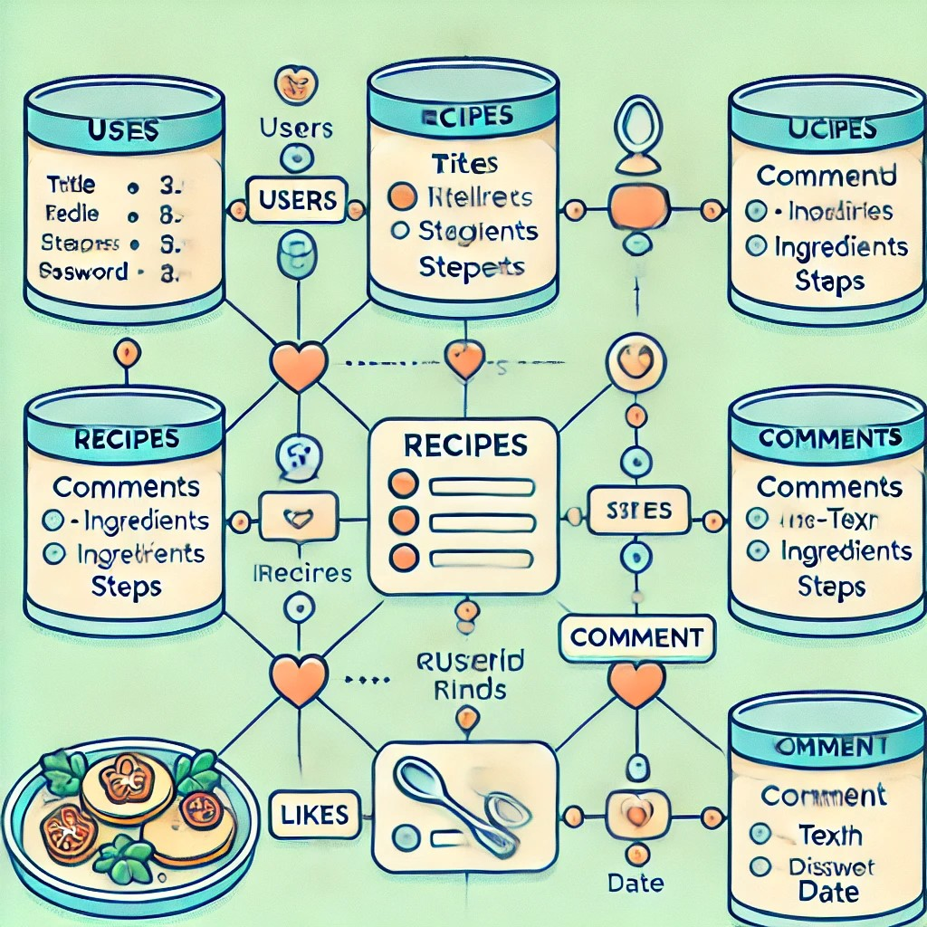

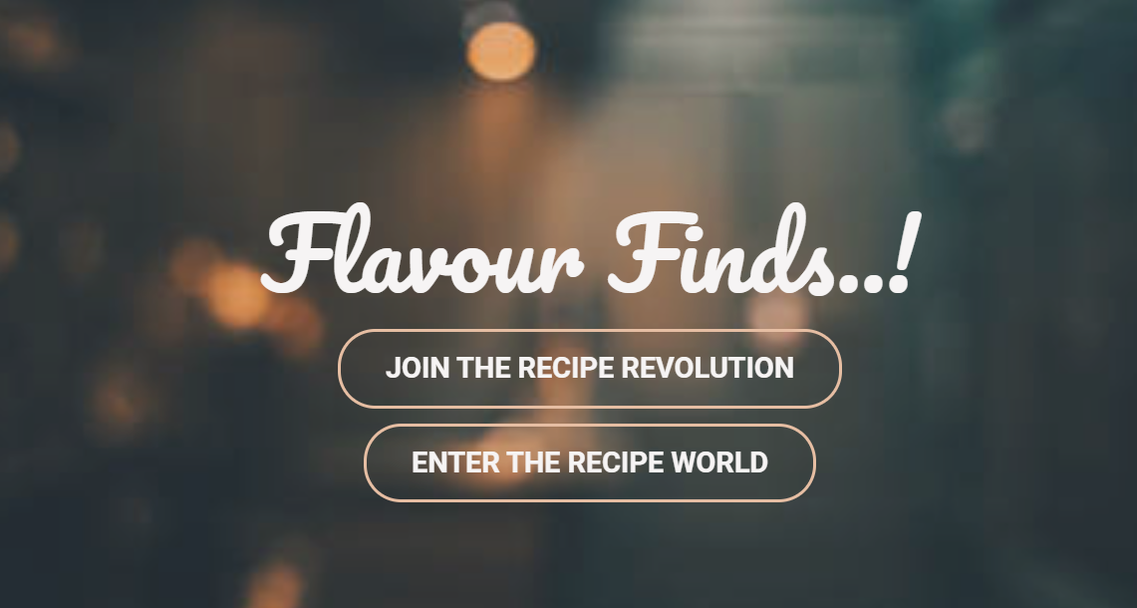**USER INTERFACE:**

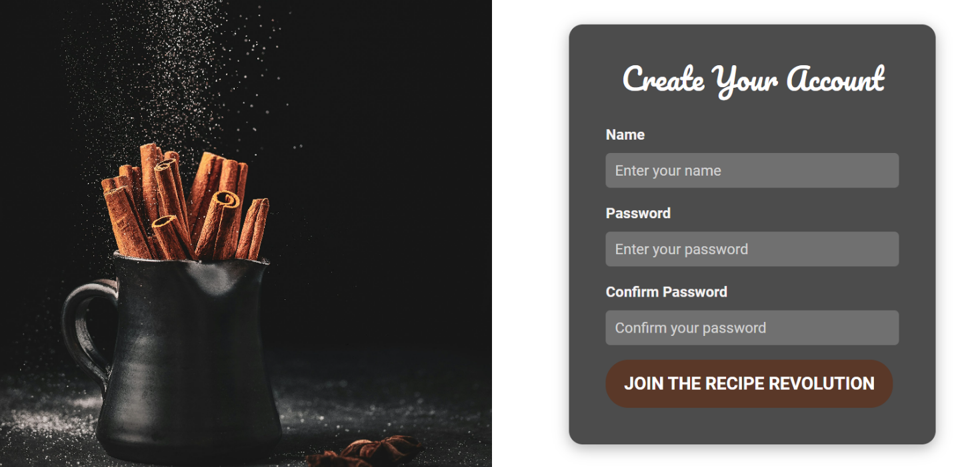

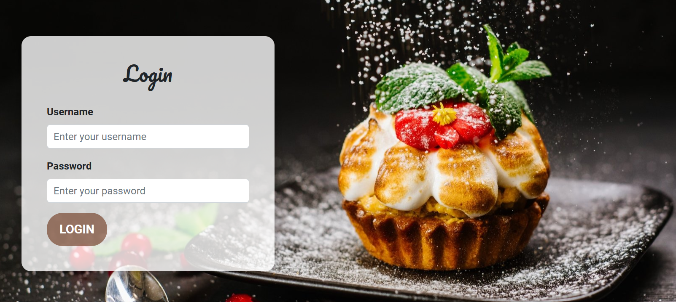

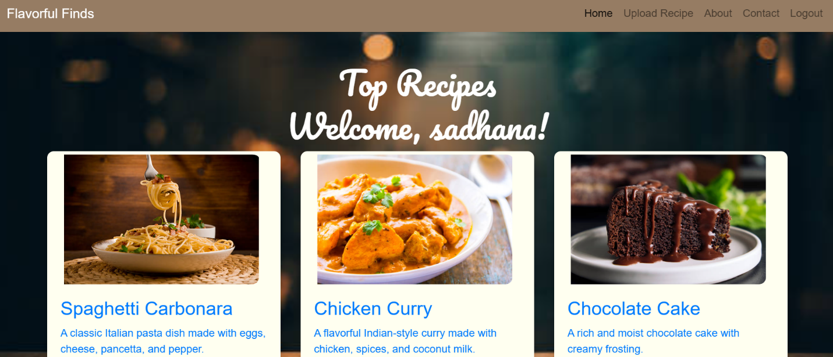

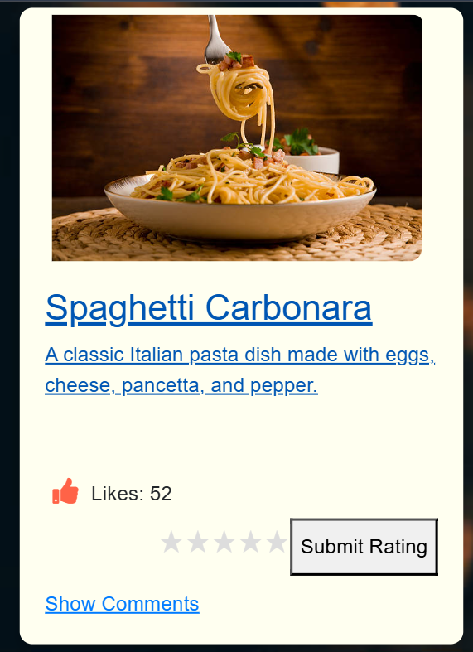

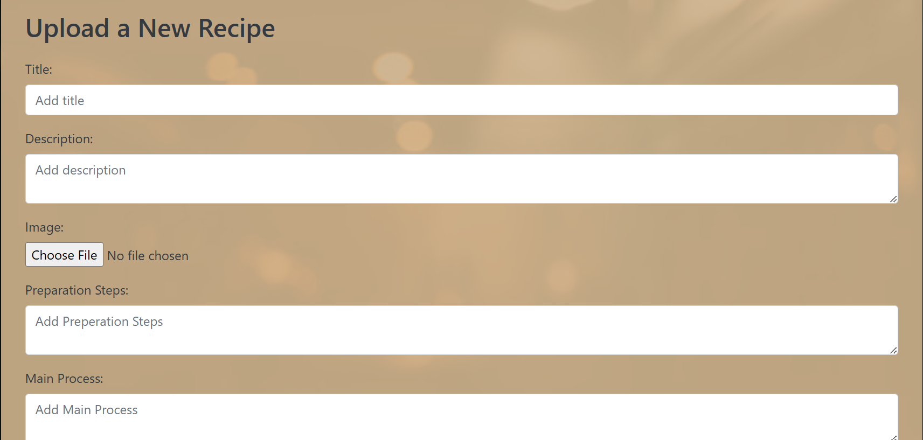



**BACKEND IMPLEMENTATION:**

The backend of the **Flavor Finds** platform is developed using PHP, which handles the server-side logic for various core functionalities. Here’s an outline of the major PHP scripts:

1. **Sign-Up Script**:
   * This script handles user registration by collecting data such as username, email, and password from the sign-up form. It performs basic validation to check if required fields are filled, ensures that the email follows the correct format, and verifies that the username and email are unique.
   * After successful validation, the script encrypts the password using hashing methods (e.g., password_hash in PHP) to ensure secure storage and then inserts the new user data into the **Users** table in the MySQL database.
2. **Login Script**:
   * The login script authenticates users by matching the input email and password with those stored in the database. It first checks if the entered email exists in the **Users** table.
   * If the email exists, it verifies the password using PHP’s password_verify function, comparing the hashed password from the database with the user’s input.
   * Upon successful login, the script initiates a session, storing user information such as userID and username to keep users logged in and allow access to their personalized content.
3. **Upload Recipe Script**:
   * This script allows users to upload recipes by submitting details such as title, ingredients, steps, and an optional image.
   * The script validates the input data, ensuring that all required fields are provided, and verifies the image format if an image is uploaded.
   * After validation, the script stores the recipe information in the **Recipes** table. The uploaded image (if provided) is stored in a designated folder, and the file path is saved in the database to ensure easy retrieval.
4. **Like Script**:
   * This script handles the "like" functionality, allowing users to like a recipe. It checks if the user has already liked the recipe (to avoid duplicate likes).
   * If the user has not previously liked the recipe, the script inserts a record into the **Likes** table with userID and recipeID.
   * It also updates the total like count for the recipe by querying the **Likes** table and displaying this count on the front end.
5. **Comment Script**:
   * The comment script allows users to add comments to a recipe by submitting text through a form.
   * It validates the comment to ensure that it’s not empty and inserts it into the **Comments** table along with the userID, recipeID, and the date.
   * Comments are then fetched and displayed with the associated recipe, allowing users to view and interact with feedback from others.

**CHALLENGES AND FUTURE SCOPE:**

**Challenges:**

1. Data Security: Ensuring secure handling of sensitive user data was a priority, using hashing for passwords and session management best practices.

2. Database Performance: Optimizing queries for larger datasets is essential for scaling, and future indexing and caching could improve efficiency.

3. Media Management: Handling user-uploaded images is challenging; a cloud storage solution could improve scalability.

4. Responsive Design: Used Bootstrap for device compatibility but could further improve responsiveness and load times on mobile.

**Future Scope:**

1. Enhanced Interactions: Add features like recipe ratings, saving favorites, and following users to boost engagement.

2. Advanced Search and Filtering: Implement recipe search by ingredients, preferences, and more. AI recommendations could personalize content.

3. Mobile App: Developing a mobile app with notifications could enhance user experience on-the-go.

4. Social Sharing: Enabling recipe sharing on social media could attract more users.

5. Cloud Storage: Moving images to cloud storage could improve performance and scalability.